There is a Swagger webpage built into the product that provides an interactive documentation of the API. It's at port 8000 of the product.

For example, there's a demo unit on the network at IP address...  192.168.1.38

The API doc is on port 8000 in the product, so enter the following in your web browser navigation bar...  192.168.1.38:8000

In order to interact with the product you must first login by scrolling down to **session/login**.

Enter the username & password for any admin account in the product. The factory default is...

u: admin

p: secret

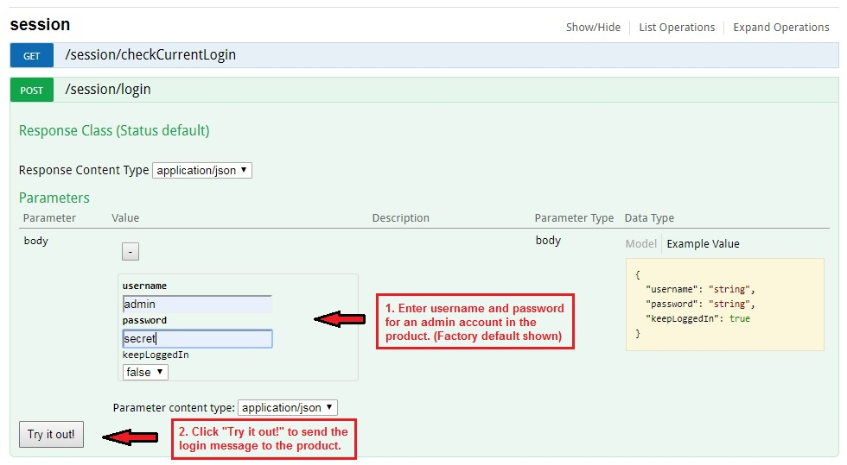

After you're logged in, the rest of the Swagger API page will provide a working interface to the product. It will show the curl code string that gets sent to the product for each message type. It will also show the reply data that comes back from the product. Post APIs are for setting/changing parameters in the product. Get APIs are for reading the status of parameters/settings from the product.